**Diabetes Prediction Using Machine Learning Algorithms.**

*#Load the dataset*

diabetes <- read.csv ("C:\\Users\\Christianah.O_BROOKS\\Downloads\\diabetes.csv", header=T, stringsAsFactors = F)

summary(diabetes)

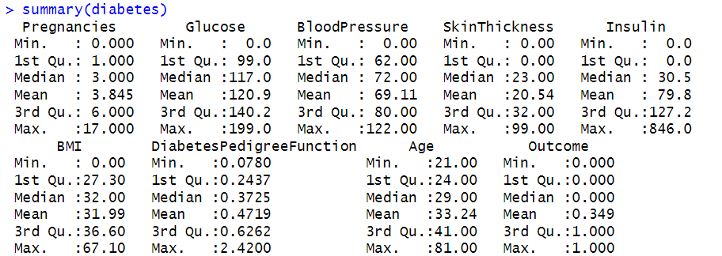

*#Basic Visualizations*

par(mfrow =c(2,2)) *# divide plotting area into 2x2 grid*

hist(diabetes$Pregnancies)

hist(diabetes$Age)

hist(diabetes$Glucose)

hist(diabetes$BMI)

par(mfrow =c(1,1)) *# reset layout*

boxplot(diabetes$BloodPressure, ylab = "BloodPressure")

install.packages("ggplot2")

library(ggplot2)

ggplot(diabetes,aes(x=Glucose))+geom_histogram(fill="skyblue",colour="black")+facet_grid(Outcome~.)

ggplot(diabetes,aes(x=Glucose))+geom_histogram(fill="skyblue",colour="black")+facet_grid(.~Outcome)

